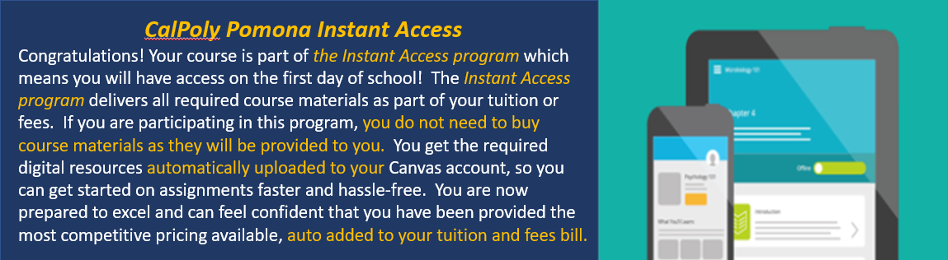

**REQUIRED TEXT**:  ***MyLab Hospitality with Pearson eText for Intro to Hospitality & Intro to Hospitality Management, 7e***

**Registration Instructions**

**(Use the code provided: DO NOT PURCHASE OR JOIN THE TRIAL PERIOD!)**

**Enter Your Canvas Course:**

1. Sign in to Canvas and navigate to the **CPP Instant Access eBook** link from the navigation area on

the left-hand side of your course.

**Please note**, this may be in a different location based on your instructor’s preference.

2. This will open your Launch dashboard where you can opt-out of the material if you are within the opt-out

deadline, or engage with your course materials.

Click the **Reveal Access Code** button to open the drawer on the right-hand side, where you can copy your access code, and access your redemption URL through the **More Info** field.

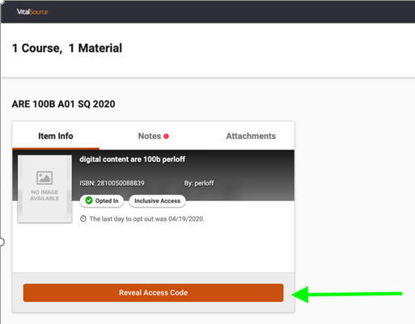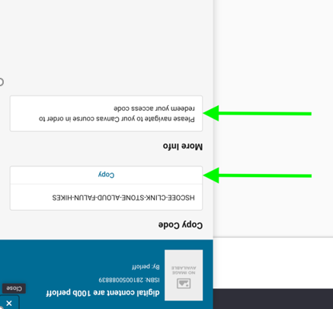

* The first time a student launches one of their digital materials, you will see a sign-on page. You can choose to create or log in to a VitalSource Bookshelf account, or continue to your digital material without registering for an account.
* You will only see this screen the very first time you launch. After that, VitalSource will remember your decision and take you straight to VitalSource Bookshelf.
* Access codes will be both emailed and available to students through VitalSource Launch in Canvas. Opting out of the material prevents the student from being billed the material and will result in the access code being considered **Inactive**.





**Once you have your access code,**

**Visit Pearson MyLab & Mastering website:**

<https://www.pearsonmylabandmastering.com/northamerica/>

**Get Access to Your Pearson Course Content:**

1. Enter your Pearson account **username** and **password** to **Link Accounts**.

You have an account if you have ever used a Pearson MyLab & Mastering product, such as MyMathLab, MyITLab, MySpanishLab, MasteringBiology or MasteringPhysics.

* If you don’t have a Pearson account, select **Create** and follow the instructions.

**-It is highly recommended that you use your CPP email-**

2. When your accounts are linked, select the option to enter an access code.

**DO NOT PURCHASE OR JOIN THE TRIAL PERIOD!**

**ENTER THE CODE PROVIDED BY VITALSOURCE**

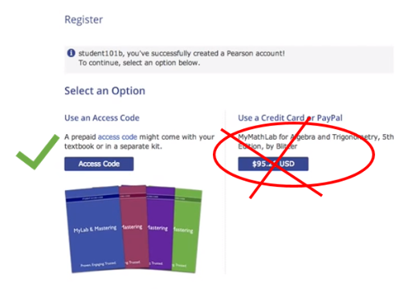

3. From the “You’re Done” page, select **Go to My Courses**.

**Need help?** For help with your Pearson Courseware with Blackboard, go to:

https://support.pearson.com/getsupport/s/

If you do not wish to participate in the program you have until ***September 3, 2021***  to "Opt Out". If you "Opt Out" of receiving and paying for your materials via this program, you will be responsible for obtaining those on your own. These are required materials for the course.

